

Lab #6 Ai Agents Types
Artificial Intelligence
SUBMITTED BY:
UBAID AHMAD
ROLL NO:
2410-0011
SUBMITTED TO:
Ma’am Wardah Asad
DATE:
17/03/2026

Task 1:
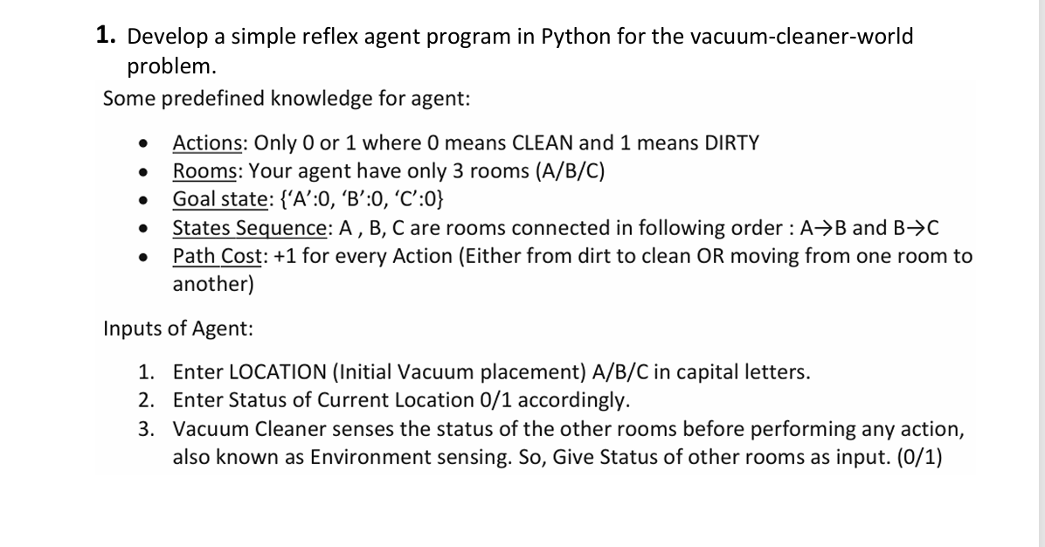
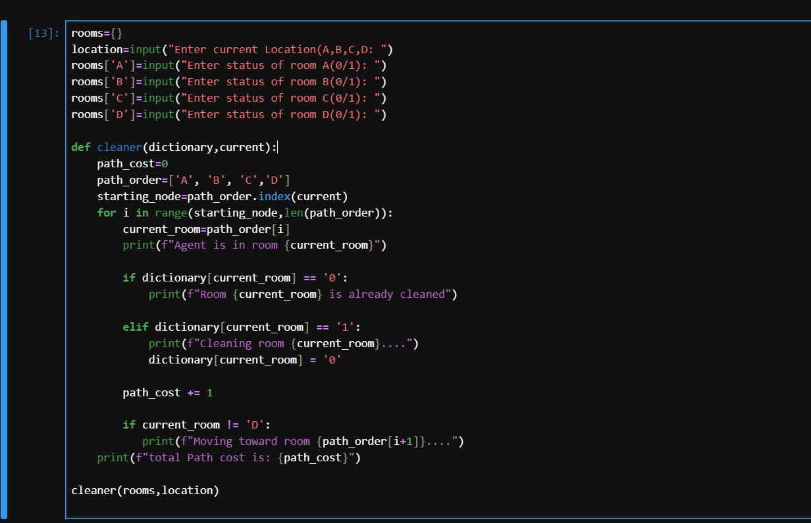
OUTPUT:
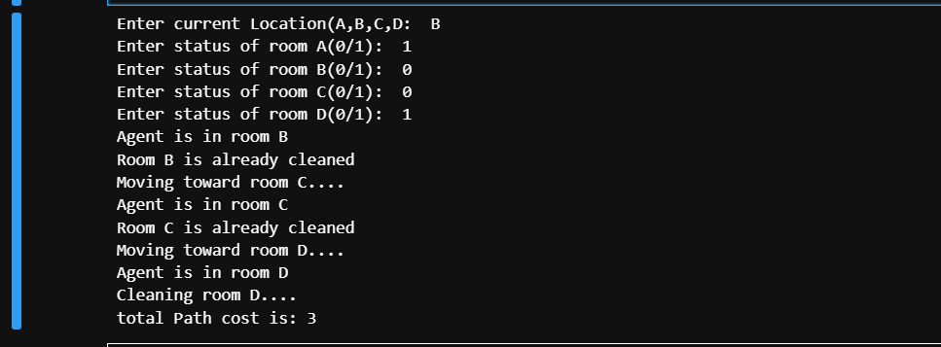

Task 2:
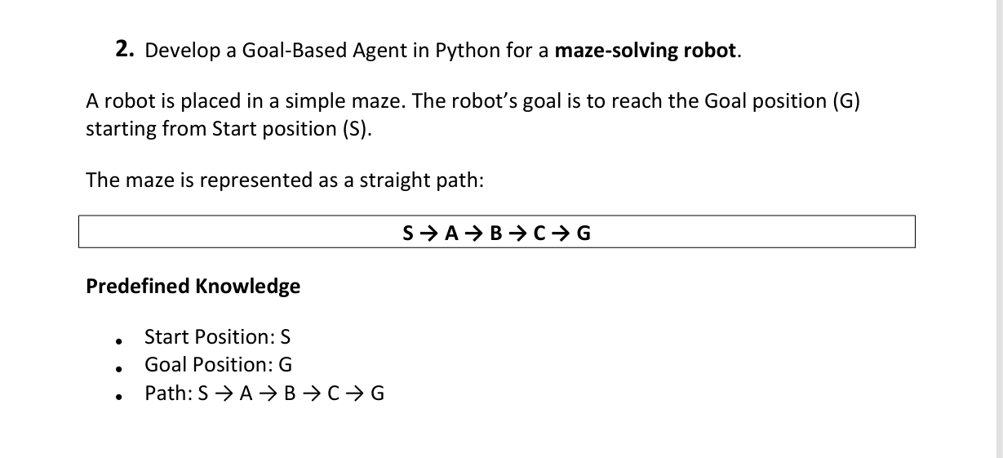
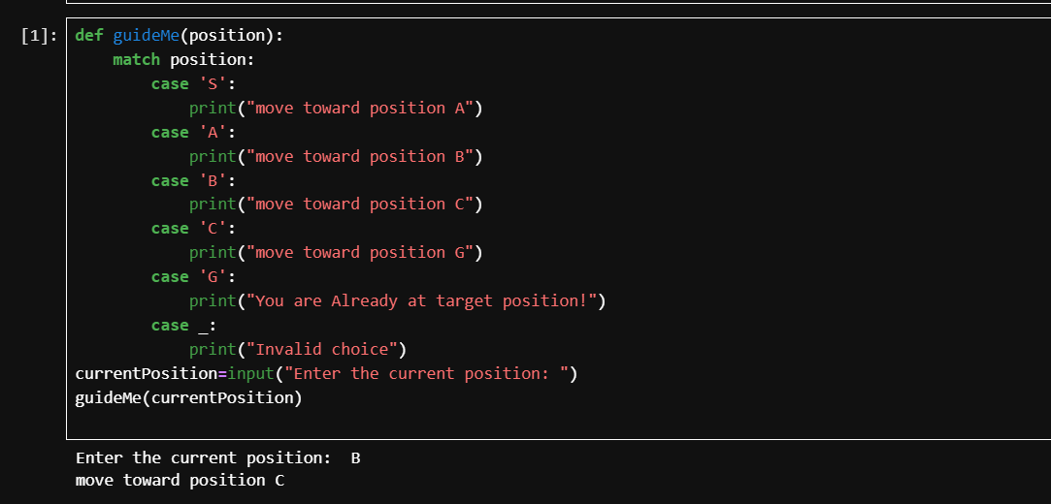
OUTPUT:

TASK 3:
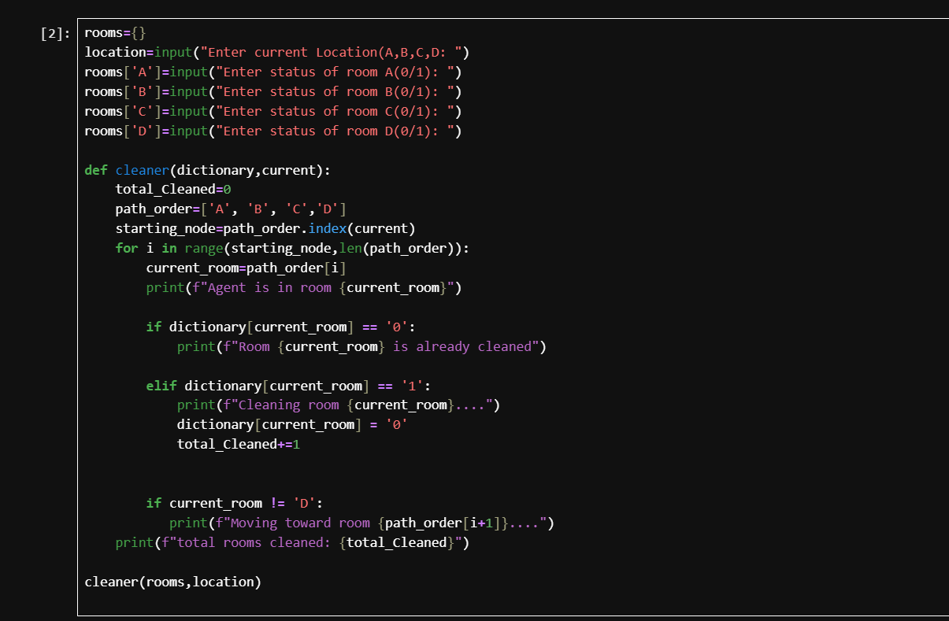

OUTPUT:
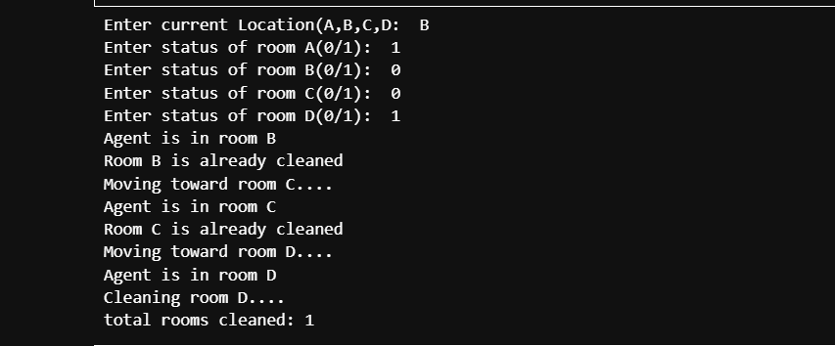
END,,,

